
Physics and Astronomy
University of Missouri Fall 2024
Communiqué

News From the Chair

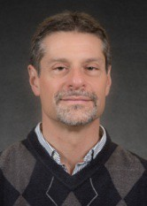
Dear Alumni, Colleagues and Friends,
Greetings from the Department of Physics and Astronomy. Many good things that have happened in our department over the past year and I will give you a quick highlight.
The Department is delighted to welcome four new faculty members, three of whom joined in the fall of 2024 and one who will join us in January 2025. Assistant Professor Pontus Laurell received his PhD in theoretical condensed-matter physics from the University of Texas–Austin and did postdoctoral work at Oak Ridge National Laboratory. His research focus is on quantum information in condensed matter systems. Assistant Teaching Professor Samual Roland received his PhD from the University of Michigan in theoretical high energy physics. Subsequently he worked in data science at
Broadcom Inc. and then taught at Stephens College. Sam is focusing his work on our large enrollment physics and astronomy courses. Assistant Professor Charles Steinhardt received his PhD in Astronomy from Harvard University, and he comes to us from the University of Copenhagen where he was associate professor in the Neils Bohr Institute. His research interests center around galactic assembly and high-redshift astrophysics. Dr. Pavlo Sukhachov will join us in January 2025 as the George H. Vineyard Assistsant Professor in Theoretical Physics. He received his PhD from the Bogolyubov Institute for Theoretical Physics in the National Academy of Sciences of Ukraine, and he subsequently held several postdoctoral positions, most recently at the Norwegian Institute of Science and Technology. His condensed-matter physics research centers on quantum materials.
This spring the Department produced its 5-year assessment for the provost’s office. It was an interesting exercise that illustrated the scholarly success and productivity of our department. In the past 5 years, the faculty published more than 520 journal articles, or 104 articles per year, with over 8300 literature citations to these articles. The faculty gave over 250 invited talks, with 150 at professional conferences and workshops, in the past 5 years. We have seven Fellows of the American Physical Society (APS) and two Fellows of the American Association for the Advancement of Science (AAAS). Our service courses are in high demand from across campus, with approximately 4000 students enrolled annually in our courses. If you would like a copy of our 5-year assessment, please contact me or the department office.
In the fall of 2024, our graduate enrollment achieved an all-time high of 65 graduate students. In the last two years, support of research assistantships by faculty has increased 30%, commensurate with increased research expenditures in the department.
Our faculty have had important professional achievements over the past year. Prof. Haojing Yan was promoted to full professor. Prof. Xiaoqin Zou was recognized by the Board of Curators as Curators’ Distinguished Professor. Prof. Guang Bian was recognized by the Chancellor’s Award for Outstanding Research and Creative Activity. Prof. Carlos Wexler was appointed as the co-Director of the MU Materials Science and Engineering Institute (MSEI), which is a collaboration between the College of Arts and Science and the College of Engineering to cultivate materials science. The MSEI has sponsored numerous seed grants to faculty in our department and others to promote collaborative research.
Many of our students have had noteworthy achievements over the past year, in fact, too many to highlight here so please read about those in the following pages and I’m sure you will join us in being very proud of both our graduate and undergraduate students.
(Continued on page 10) 1

Campus and Community Outreach

Eclipses
Our planet experiences two eclipse seasons annually when the Moon’s orbital path crosses directly between Earth and the Sun. Our location afforded us viewing and outreaching opportunities for both most recent eclipses, with a 60% partial view of last November’s (2023) annular solar eclipse and an almost 95% totality experience for the April 8, 2024, total eclipse.
Our professors and graduate students set up viewing stations on Lowry Mall with telescopes and eclipse glasses during each event.

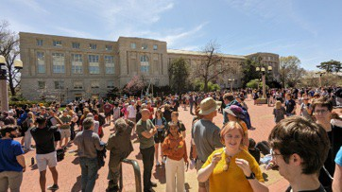
April 8th:Mizzou Physics and Astronomy graduate students and faculty host an eclipse viewing party at a crowded Lowry Mall. Photo credit – Paul Miceli

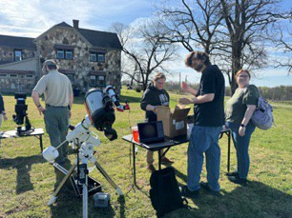
For the solar eclipse in April graduate students Gourab Nandi, Manoj Gadtoula, and Jenna Bologa, faculty members Haojing Yan and Silvia Bompadre along with many other students ran the event with telescopes and demonstrations at Lowry Mall and interacted with about 750 visitors.

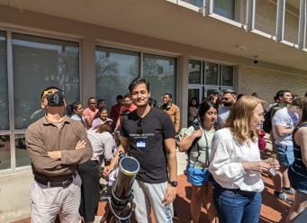
Haojing Yan, Gourab Nandi, Silvia Bompadre at Lowry Mall. Photo credit – Paul Miceli
Two groups of our graduate students traveled to the path of totality in southern Missouri on April 8. Charles Mentzer, Alec Martin, Bangzheng Sun, and Bo Yang set up telescopes and provided information at the new Eleven Point

Alex Martin and Charles Mentzer (foreground) help with eclipse information at Eleven Point State Park. Photo by Bangzheng (Tom) Sun.

State Park for about 250 visitors. Teja Teppla participated in a huge fair in Poplar Bluff which had about 1,000 visitors.
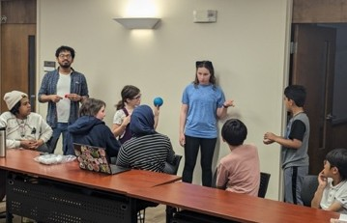
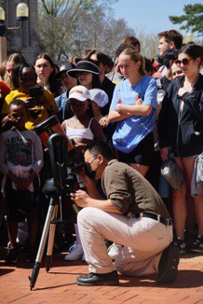
Professor Yicheng Guo coordinated these events that reached more than 2,500 Missourians.

Prof. Haojing Yan adjusts the telescope during the eclipse - Photo credits - Frida Qi (graduate student in the School of Journalism, on Instagram as @frida_qi_photography/ Website: https://journalism.missouri.edu/people/fr ida-qi-xin-qi/ @frida_qi_photography)

Event organizer Teja Teppala and students in Columbia in March at a pre-eclipse 4-H event.
2

Annual Open House
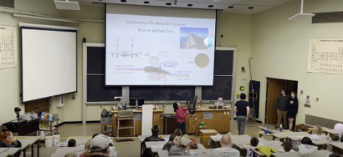
Our Department of Physics and Astronomy held the annual Open House event on Saturday, April 20, 2024. The event was led by faculty members Yun Zhang and Yicheng Guo, and three graduate students Teja Teppala, Charles Mentzer, and Dylan Chiaro. Fifteen additional volunteers (7 graduate students from PAGSA and 8 undergraduate

students from SPS) made significant
Prof. Yun Zhang demonstrates how an airplane ﬂies to attendees.

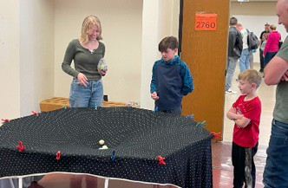
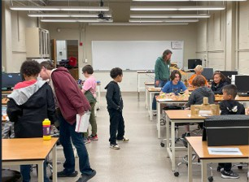
contributions to the success of this event. This event attracted an estimated attendance of 150 adults and children. Participants explored more than 50 hands-on displays of Physics and Astronomy, built kaleidoscopes, and made color subtraction pictures. They watched eye- opening large scale physics demonstrations as well as fun demonstrations using liquid nitrogen, enjoying ice cream made on the spot.

Our physics students helped with demonstrations and displays.

Laws Observatory

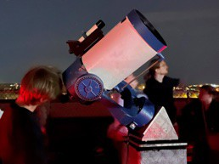
Rooftop activity with Celestron 10 scope on,March 6
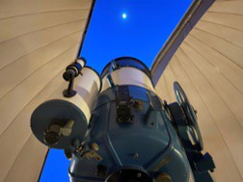
16" Celestron Schmidt-Cassegrain telescope in the dome ready for lunar viewing on April 17. Giant crater Clarius, including small craters in its floor showed up in the view.
Laws Observatory on top of the Physics Building continues to be used for outreach and education on a weekly basis. Wednesday night viewing for the public is open (weather permitting) all year except during the coldest months and during
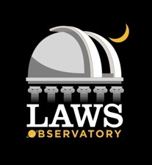
a mid-summer break. Upgrades to some of the rooftop scopes this year
included modifications for a handicapped accessible scope. There are many other activities for special events. The observatory provided live streaming on Facebook during the April 8 solar eclipse. The events are run by student volunteers and by Valentine Germann and Randall Durk of the Central Missouri Astronomical Society.
For news and information follow Laws Observatory on Facebook. More information is also available on the observatory webpage: https://physics.missouri.edu/laws-observatory
3

New Arrivals Enlarge Department

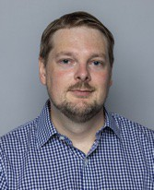
Dr. Pontus Laurell joined our department this fall as an assistant professor, coming from a postdoc in theoretical condensed matter physics at the University of Tennessee, Knoxville. He has a bachelor's degree in engineering physics and a master's degree in fundamental physics from Chalmers University of Technology, in Gothenburg, Sweden. He received his physics PhD in 2018 from the University of Texas at Austin with Prof. Gregory Fiete. From graduation until 2021, he was a postdoc at Oak Ridge National Laboratory, where he developed strong collaborations with quantum magnetism experimentalists, and a deep
interest in applications of quantum information methods to quantum materials and high- performance computing.

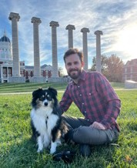
Dr. Sam Roland joined our department as an assistant teaching professor, beginning fall semester 2024. Prior to this he was an Assistant Professor of Mathematics and Physics at Stephens College. He earned his B.A. in physics and mathematics from Cornell University. He received his Ph.D. in theoretical physics from the University of Michigan, where he investigated the origins of dark matter in the early universe, moments after the big bang. He also led the undergraduate physics labs at the University of Michigan, designing lessons and building equipment for hands-on
learning. Before joining Stephens College, Dr. Roland worked as a data scientist, applying machine learning and artificial intelligence to fight online credit card fraud.

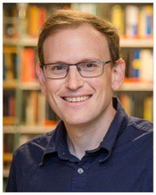
Dr. Charles Steinhardt joined the department this fall as an assistant professor from his prior position as Associate Professor, Cosmic Dawn Center, Niels Bohr Institute, University of Copenhagen where he worked on a variety of problems in high- redshift astrophysics, other areas of astronomy, astrostatistics, and machine learning. He was a founding member of the Cosmic Dawn Center, a Danish National Research Foundation Center of Excellence hosted by the Niels Bohr Institute and Danish Technical University. He is a co-PI of BUFFALO (Beyond Ultra-deep
Frontier Fields And Legacy Observations), an astronomical survey built around the six Hubble Space Telescope (HST) Frontier Fields clusters designed to learn about early galactic assembly and clustering and prepare targets for observations with the James Webb Space Telescope. He received an A.B. in Astrophysical Sciences from Princeton University, and
S.M in Astronomy, S.M. in Computer Science, and Ph.D. in Astronomy from Harvard
University.

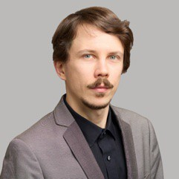
Dr. Pavlo Sukhachov has accepted the position of George H. Vineyard Assistant Professor of Theoretical Physics and will officially begin in January. Until then he continues as a Postdoc at the QuSpin Center of Excellence in the Norwegian University of Science and Technology. He received his PhD from the Bogolyubov Institute for Theoretical Physics of National Academy of Sciences of Ukraine in 2016. Before joining NTNU in 2024, he held a few postdoctoral positions at Western University (Canada), Nordita (Sweden), Yale University, and the University of California, Santa Cruz.
His main research interests concern topological quantum materials exemplified by Dirac and Weyl semimetals. He is interested in transport properties, collective modes, surface states, superconductivity, and magnetism.

Welcome

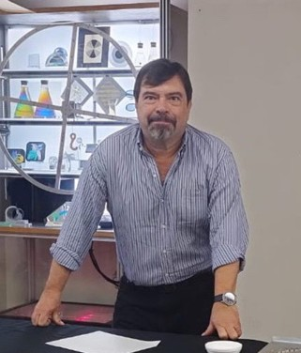
Beginning in August 2024: Prof. Karim Sapag is spending one academic year in the Department as a Fulbright Scholar-in-Residence awardee hosted by Prof. Carlos Wexler. The Fulbright Scholar-in- Residence Program brings visiting scholars from abroad to U.S. colleges and universities, helping the institutions internationalize their curricula, campuses and surrounding communities, and diversify the educational experiences of their students, faculty, staff, and stakeholders. Prof. Sapag is one of forty-three Fulbright Scholars-in-Residence, and among 1,000 outstanding foreign faculty and professionals who will teach and pursue research in the United States for the 2024-2025 academic year through the worldwide Fulbright Visiting Scholar Program.
While at Mizzou, Sapag will teach two physics courses in collaboration with Carlos Wexler, professor of physics, and teach seminars regarding international scientific collaborations, while enhancing outreach to Columbia Public School students at Centro Latino.
(from showme.missouri.edu.)

Faculty News & Recogni:on

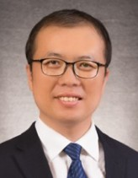
Sciences.
Associate Professor Guang Bian was chosen as the 2024 recipient of the Chancellor’s Award for
Outstanding Research and Creative Activity in the Physical and Mathematical
Technology of Synthetic Electronics Materials in Dresden, Germany, and the Optica Advanced Photonics Congress in Quebec City. She has been invited as a plenary speaker for the 2024
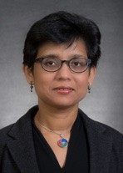
Autoorg Meeting in Self Assembly Structures,

The Moore Foundation granted Bians’ group an equipment funding of $150,881 in August, 2024. The funding is for the acquisition of an ARS Low-T UHV Nanoscience Probe Station. The probe station is equipped with a closed- cycle cryostat (4.2 K), UHV (<10⁻¹⁰ Torr), multiple probe arms, and an optical window. It is capable of various transport and optical measurements at 4.2K and UHV conditions.
The equipment will be connected to the existing MBE system in Bian’s lab. This will mark the first-of-its-kind in situ MBE- ARPES-STM-TRANSPORT-OPTICS
(MASTRO) 5-in-1 nanoscience system!
Jacob Cook, a graduate student from Prof. Bian’s group, has been selected to receive the
which will be held in Santos, Sao Paulo. Prof. Wendel Alves from the Federal University of ABC, Sao Paulo, spent three months in MU working with Suchi’s group on biosensors.
Graduate student, Randy Burns, successfully defended his PhD in summer 2024 and has recently joined Intel Inc. as a process
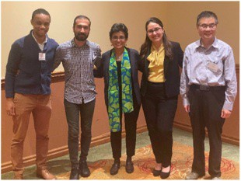
engineer.
Other graduate students working in her group: Arash Ghobadi and Dallar

2024 U.S. Department of Energy (DOE)
Randy Burns, Arash Ghobadi, Suchi Guha,
Dallar Babaian, Ping Yu
Babaian (co-
advised by

Office of Science Graduate Student Research (SCGSR) award. Jacob will conduct the sponsored project "Moiré confinement of strain-induced topological phase transitions in 2D Van der Waals materials” at Oak Ridge National Laboratory (ORNL).

Professor Suchi Guha has been working on several new research projects focused on neuromorphic organic devices, and ultrafast and nonlinear spectroscopy. She gave several invited presentations in 2024 including the APS March Meeting in Minneapolis, Nanoseries Conference in Lisbon, Portugal, the International Conference on Science and
Prof. Ping Yu) presented their work at the 2024 APS March Meeting and have authored/co-authored several publications.
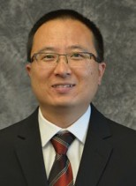
Associate Professor Yicheng Guo studies the morphology of galaxies in the early universe using the data of the James Webb Space Telescope.
His group published a paper in the Astrophysical Journal Letters about their
surprising discovery that spiral galaxies, similar to our Milky Way, had already been

prevalent in the universe when it was only 2 billion years old. This result changes people's view that spiral galaxies only appear in large numbers in the recent universe. The first author of the paper, graduate student Vicki Kuhn, presented it in the press conference of the 244th Meeting of the American Astronomical Society in Wisconsin in June, 2024. The paper was then reported widely by worldwide media, including Forbes, MSN.com, Sky & Telescope, etc., potentially reaching 200 million people.
With the help of graduate students (particularly Teja Teppala, Charles Mentzer, Bangzheng Sun, and Gourab Nandi) and other faculty members, Dr. Guo coordinated the efforts of holding viewing parties for two solar eclipses (2023/10 and 2024/04) in a few locations in Missouri, accessing more than 2,500 Missourians.
Graduate student Teja Teppala received many awards for his constant dedication to public engagement, outreach, and educational programs, including:
- 04/19/24: Tapped into the Rollins Society Class of 2024 at the 97th Tap Day.
- 04/24/24: Received the Sandra K. Abell Science Education Award, and the Mary Elizabeth Gutermuth Award for Community Engagement from the Mizzou Graduate School at the 10th Annual Graduate and Postdoctoral Awards.
- 06/27/24: Received the Remington R. Williams Award from the Board of Curators of the University of Missouri System.
- 07/05/24: Selected as an ALMA
Ambassador with the North American ALMA Science Center (NAASC), National Radio Astronomy Observatory.
Undergraduate students Ellie Gates and Julianna Bayless were selected to represent Mizzou to introduce their research to the
legislators of Missouri in the 2024 Undergraduate Research Day at the Missouri State Capitol. Their research uses a serendipitously discovered galaxy-galaxy gravitational lensing system in JWST images to unveil the mysterious dark matter.
Undergraduate Jayden Francois was offered Mizzou’s 2024 Award for Academic Distinction, one of the highest honors MU offers based on academic distinction.
Students from Guo’s group actively participated in professional conferences. Alec Martin presented his work in several conferences; Vicki Kuhn won 3rd place in the graduate competition of the Physical and Mathematical Sciences Division at the Show Me Research Week; Jayden Francois won 1st place in the undergraduate competition of the same event.
Dr. Guo and Vicki Kuhn were on the organizing committee of the American Physical Society’s Conference for Undergraduate Women in Physics (CUWiP) held at Missouri S&T, Rolla, MO. This three-day regional conference’s goal is to help undergraduate women continue in physics by providing them with the opportunity to experience a professional conference, information about graduate school, and professions in physics.
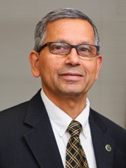
Professor Kattesh Katti completed work on a grant in South Africa as a Fulbright Specialist. Selected to the U.S. Department of State Fulbright Specialist Program, Katti led nano-
ayurvedic medicine research at the University of Johannesburg in South Africa from July 2 - Aug. 12. He is recognized as one of the world’s leading experts in green nanotechnology and nanomedicine.

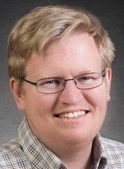
In the summer of 2024 Professor Gavin King’s laboratory bid a heartfelt farewell to three excellent and longstanding researchers: Dr.
Katherine Schaefer (PhD 2022, Postdoc
2022-2024), Dr. Dylan Weaver (PhD 2024), and Elizabeth Conley (BS 2024).
Dr. Schaefer’s research in the lab involved developing and deploying advanced single molecule atomic force microscopy techniques to reveal drug-induced membrane protein conformational dynamics as well as to visualize the mechanism of infections emanating from the common yeast, Candida albicans. This latter line of inquiry resulted in high- profile publications including a manuscript just accepted in Nature Microbiology. Dr. Schaefer is currently pursuing a Doctor of Medicine degree at Washington University in St. Louis, where she obtained a full scholarship.
It should also be noted that in addition to her scientific research prowess, Dr.
Schaefer is an outstanding artist. Some of Dr. Schaefer’s artwork currently hangs in the King Laboratory (feel free to stop by and take a look!) and her portrait of Prof. Dorina Kosztin is displayed in the Physics Library.
Dr. Dylan Weaver’s research in the King lab focused on fundamental studies of protein-lipid interactions. His main PhD work, which was carried out in close collaboration with Prof. Ioan Kosztin’s group, revealed how the length of a protein chain influences the force required to remove the protein from the bilayer.
In fall of 2024 Dr. Weaver started a tenure track Assistant Professorship in the Physics Department at the University of Wisconsin, Eau Claire. All the best to Prof. Weaver as he starts out at his new post!
Elizabeth Conley worked in the King laboratory for several years as an undergraduate researcher. In the course of her research Conley identified several shortcomings of a conventional software package used to analyze atomic force microscope images of polymers. Frustrated by the limitations of the existing software, Conley developed her own method to overcome the drawbacks. We currently have a manuscript under review (with Conley as first author) describing the details of her new algorithm called “PS Poly”.
All of these contributions were made possible by grants from the NSF, NIH, and the MU Research Excellence Postdoctoral Program.

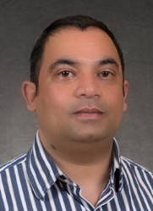
Associate Professor Deepak Singh's work on magnetism in nickel monosilicide was highlighted on the
U.S. Department of Energy's website, titled
“A Surprising Discovery: Magnetism
in a Common Material for Microelectronics”.
For the first time, Singh’s research group discovered magnetic order at high temperature in a metal widely used by the electronics industry. Harnessing the newly discovered magnetism of NiSi in semiconductors may lead to faster computers and computer memory.

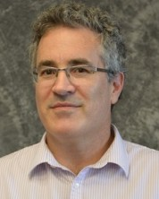
In March, 2024, Professor Carlos Wexler was appointed Co-Director of the University of Missouri Materials Science and Engineering Institute

(https://msei.missouri.edu/). Also in March, Wexler received the Ann K. Covington Award for Mentoring. The award recognizes members of the university faculty or staff who have mentored an undergraduate applicant for at least one nationally competitive fellowship.
In May, Mr. Corey Valleroy, an undergraduate researcher in Wexler’s lab, received the University of Missouri Award for Academic Distinction (https://undergraduatestudies.missouri.edu/dis tinction/) for his senior thesis and paper “Temperature dependence of the near infrared absorption spectrum of single‐wall carbon nanotubes dispersed by sodium dodecyl sulfate in aqueous solution: experiments and molecular dynamics study” (J. Mol. Model. 30, 286 (2024). Valleroy also received the Student Presentation Prize Award from the American Physical Society Prairie Section Fall 2023 Meeting. Mr. Valleroy is currently working as an Optical Engineer at the University of Minnesota.
Beginning in August, Prof. Karim Sapag will be spending one academic year at the Department as a Fulbright Scholar-in- Residence awardee hosted by Prof. Wexler. Prof. Wexler chaired the American Physical Society Prairie Section meeting hosted by our Department of Physics & Astronomy

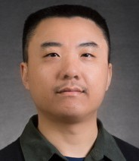
Professor Haojing Yan was promoted to full professor in September 2024. He has continued leading his team using the data from the James Webb Space Telescope to explore the early Universe.
found a potential filament structure at redshift of 8.3 (corresponding to 610 million years after the Big Bang), signposted by four "infant" galaxies (less than 30 million years old) crunched into a small volume. These are the youngest (albeit not the earliest) galaxies ever reported in the literature; in other words, we are witnessing the structure in the making. The team has also identified a disk-shape galaxy at redshift of 5.289 (1.1 billion years after the Big Bang), a very early time that the previous theoretical models all said that disk- shape galaxies (i.e., systems dominated by rotation but not random motion) would not have come into being. This galaxy is the second highest-redshift disk galaxy confirmed to date, coming short by only 0.1 in redshift to the champion.

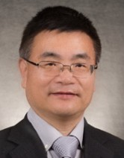
Professor Ping Yu, along with professors Suchi Guha and Paul Miceli, submitted a proposal to the Mizzou Student Success Enhancement Program resulting in a $100,000 grant for the Reese Optics Laboratory in our
department, along with an additional departmental cost share of $17,196. The proposal focuses on enhancing the functionality of the Reese Optics Laboratory, located in room 217 of the Physics Building. The planned upgrades include expanding the space to support more hands-on student experiments, acquiring new instruments for laser and quantum optics, and replacing outdated equipment and computers.
Yu has received a Laser Lab Award from Gentec-EO for his course, Light and Modern Optics. The company has selected 12 institutions from academic organizations worldwide for this award. As part of the award, Gentec-EO will provide a portable photodiode-based laser power meter, valued at
$1,500, to support hands-on experiments in the course.

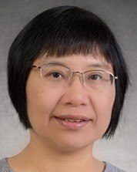
Professor Xiaoqin Zou has been recognized by the University of Missouri Board of Curators as a Curators’ Distinguished Professor. The professorship is the highest and most prestigious academic rank the Board of Curators
awards. It is awarded to a select few outstanding scholars with established reputations
Abeeb Ajibade, a physics graduate student in
Scholarship, funding him as a University of Missouri/University of the Western Cape exchange student for two months. These scholarships are generally awarded annually to one UM System student for study at the University of the Western Cape and one University of
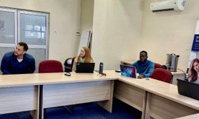
the Western Cape student for study at any campus of the University of

Zou’s laboratory, received the Henry Mitchell
Missouri
System.
Abeeb (center right) attending Professor Jacques Joubert’s team meeting at the University of the Western Cape.

(News from the Chair, Cont. from page 2
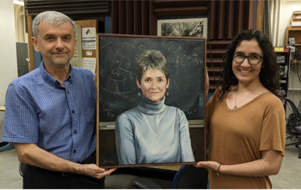
Professor Joseph Willett, who was a Physics and Astronomy faculty member from 1965 to 2004, passed away at age 94 on Nov. 6, 2023. Prof. Willett did theoretical research in plasma physics related to nuclear fusion and he was an admired teacher. He also was an accomplished jazz musician who was well-known in the community. More information about Joe is in the newsletter.
The department received a wonderful and precious gift from our recent graduate, Dr. Katherine (Katie) Schaefer, who received her PhD in Biophysics (2022) and who was a student of Prof. Gavin King. A highly accomplished artist, Katie created an oil painting on canvas of the late Prof. Dorina Kosztin who passed away in January 2023. Katie created a remarkable likeness of Dorina positioned in front of a blackboard, using photographs and Dorina’s written materials as reference. The framed painting (frame provided by current

graduate student Sadie Nickles) is displayed in our Physics Library. We are very grateful for this cherished gift.
Dr. Katherine Schaefer (right) and Prof. Ioan Kosztin (left) holding Katie’s painting of the late Prof. Dorina Kosztin.


There are an array of developments and happenings in the department. Missouri Women in Physics and Astronomy (MoWiPA), led by Prof. Maria Mills, is a new group that was formed to support and connect women faculty and graduate students. In December 2023 the department hosted the American Physical Society Prairie Section Meeting. Prof. Carlos Wexler organized the meeting, which drew approximately 200 participants and included a well-attended public lecture prior to the meeting. Our annual Physics Leaders Meeting was held October 11and 12 of 2024 where the Distinguished Alumni Award was given to Ronald Boain who had an illustrious career in developing rocket trajectories (including the Apollo program) and who has been a strong supporter of our department. In April 2024 Profs. Yun Zhang and Yicheng Guo, along with many graduate students, hosted our annual open house that attracted 150 participants from the community where they engaged in over 50 hands-on physics and astronomy demonstrations. Also in April, our graduate students and faculty were heavily involved in outreach for the total solar eclipse. They fanned out to various parts of the state as well as organized a viewing on Lowry Mall where there was a large turn out from the campus community. The Physics and Astronomy Graduate Student Association (PAGSA) remains very active. They and the department continue to organize several social events (picnics, Thanksgiving dinner, and luncheons) during the year. Through astronomy students and the enthusiastic support of volunteers Randall Durk and Valentine Germann from the Central Missouri Astronomical Society, the Laws Observatory continues to hold the popular Wednesday night viewings for the public.
On behalf of the Department of Physics and Astronomy, I wish all our friends and alumni the very best for

Collabora:ve Research at MU

The MU Science and Engineering Institute was launched in 2022 to develop new and improved materials and to foster collaborative research. Only recently was it announced that the institute will be co-led by Matt Maschmann, an associate professor of mechanical and aerospace engineering, and Carlos Wexler, a professor of physics in the College of Arts and Science.

The MUMSEI is a collaboration between the Department of Physics & Astronomy and the College of Engineering in existing and new areas, including biomaterials, energy materials, quantum materials and materials-at-extremes. By uniting the sciences and engineering at Mizzou, the institute will create new opportunities for joint projects and funding proposals.

Numerous facilities are open and available to both researchers and industry professionals. Additionally, affiliated faculty develop new interdisciplinary academic programs such as certificates and graduate degrees in materials science and engineering to prepare students to work and research in these areas. The Department of Physics & Astronomy has several faculty designated as core or affiliated faculty with MUSEI. More information is available at https://MSEI.Missouri.edu.

APS Prairie Section Meeting hosted by DPA

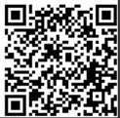
From November 30 –December 2, 2023, the Department hosted the American Physical Society Prairie Section Meeting. Prof. Carlos Wexler chaired the conference. The conference was opened by President Mun Choi and started with a public lecture “The Quantum and the Cosmos” by Edward “Rocky” Kolb (U. Chicago) attended by over 250 people. The conference had 14 invited and 45 contributed talks, and 36 posters and was attended by almost 200 scientists.
For more information and photos of the event scan the QR code.

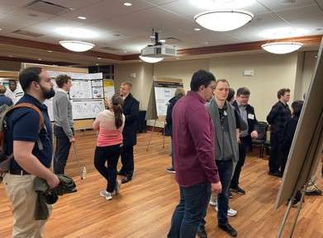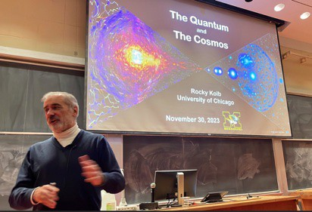

Poster session in Memorial Union
Dr. Rocky Kolb presents “The Quantum and the Cosmos”

Undergraduate Degrees
Our Graduates
Fall 2023
Logan Chambers, Summa Cum Laude, emphasis in Astronomy
Spencer Griffin Kobe Knisley Cameron Mondl Blake Peters,
Carson Ziemke, Cum Laude

Spring 2024 BA
Noah Lively, Summa Cum Laude, Honors College Certificate
BS
Preston Barron
Jude Huck-Reymond, Cum Laude
Joseph Burglund, Summa Cum Laude, emphasis in Materials Science, Department Honors
Daniel Blevins, Magna Cum Laude, emphasis in Materials Science, Department Honors
Samuel Cheslik, Magna Cum Laude, emphasis in Materials Science
Elizabeth Conley, Department Honors
Matthew Dygert, Magna Cum Laude, emphasis in Astronomy, Honors College Certificate
Jayden Francois, Magna Cum Laude, emphasis in Astronomy, Honors College Certificate
Nicholas Gardner
Jayden Grisham, emphasis in Astronomy Patrick Hayden, emphasis in Astronomy Hayden Higgins, Summa Cum Laude Erika Hilario
Luke Lindberg, Summa Cum Laude, emphasis in Materials Science, Honors College Certificate
Logan Murray, emphasis in Astronomy
Maximus Sanson, emphasis in Astronomy, Honors College Certificate
Riley Satterfield, emphasis in Materials Science
Asher Smith, Magna Cum Laude, emphasis in Astronomy, Honors College Certificate
Mikaela Thompson, emphasis in Astronomy
Corey Valleroy, Summa Cum Laude, Department Honors

Departmental Honors requires > 3.5 GPA in physics courses, completion of 6 credit hours of research, and a publication or presentation (oral or poster).

A Certificate in General Honors from the MU Honors College requires students to complete 24 hours of courses for honors credit and maintain a 3.5 cumulative GPA.

To receive Latin honors from our College of Arts and Science requires at least 54 of the student’s last 60 hours at MU and:

  - – 3.799 GPA for Cum
Laude
  - – 3.899 GPA for Magna Cum Laude
  - – 4.0 GPA for Summa Cum Laude

Graduate Degrees
PhD Graduates:
Fall 2023
Jason Guo
Spring 2024
Dylan Weaver
Summer 2024
Ryan Smith, Randy Burns

Where are our graduates?

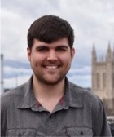
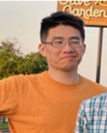
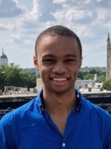
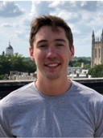
Jason Guo, PhD, Fall 2023: Postdoc at Oakridge National Laboratory, Advisor Deepak Singh. Research thesis: Elucidation of the Quantum Magnetic dynamics in semi-classical honeycomb lattice.

Dylan Weaver, PhD Spring 2023: Assistant Professor at University of Wisconsin-Eau Claire, Advisor Gavin King. Research Thesis: Probing membrane protein dynamics and interactions with lips at the single molecule level.

Ryan Smith, PhD. Summer 2024: Veterans United, Advisor Ioan Kosztin, Research thesis: Theoretical and computational modeling of the interactions of peptides and proteins with lipid bilayer surfaces.

Randy Burns, PhD. Summer 2024: Intel Corporation, Advisor Suchi Guha. Research thesis: Structural and electronic properties of hybrid halide perovskites: insights into chemical vapor deposited films.

8.4%

9.5%
Faculty
Other Teaching Postdocs/Staff Scientists Industry/Business
Other



4.2%

34.7%

43.2%

PhD Physics, U. Missouri (2010 - 2024) - 95 students

Student Awards, Scholarships, & Recognition

These fellowships, scholarships, and awards are possible because of funds generously established and supported by our alumni and faculty.

These students were the recipients for the academic year 2023-2024 and summer 2024.

All funds do not have scholarships awarded every year.

Graduate Student Scholarships
Carl & Brynn Anderson Graduate Student Award Fund in Physics
Undergraduate Student Scholarships

Paul E. Basye Undergraduate Scholarship Vishvi Aurora, Hayden Higgins, Ashley Morrison Asher Smith, Carter Woods

Samuel S. Laws Scholarship
Jayden Francois

Donald L. and Lona Lewis Packwood Endowed Undergraduate Scholarship Fund in Physics Julianna Bayless, Joseph Berglund

Melvin Y. Mora Undergraduate Scholarship Fund
Donovan Flagg

Clifford W. Tompson Scholarship in Physics Donovan Flagg, Jayden Francois, Luke Lindberg Corey Valleroy
David Beckwitt, Bo Yang

Armstrong Physics Endowment
Bradley Faison

Rose Marie Dishman Endowed Scholarship in Physics
Dallar Babaian, Pousali Ghosh
James L. and Dora D. Fergason Fund for Excellence in Physics:
Abhi Abhijeet, Tony Dorhauer, Manoj Gadtoula, Dilan Gamachchige, Hriday Joni, Indeewari Kariyapperuma, Dayton Simpkins, Kishlay Singh, Carson Ziemke

Newell S. Gingrich Physics Scholarship Fund
Charles Mentzer, Pavel Morales, Teja Teppala, Bo Yang

Newell S. Gingrich Physics and Astronomy Endowment Harold Diaz-Quiroz, Tapesh Gautam, Mari Tsumuraya, Jared Williams
Eli Stuart Haynes and Nola Anderson Haynes Scholarship Fund
Charles Mentzer, Teja Teppala

Eugene B. Hensley Scholarship in Physics
David Beckwitt

Ernest W. Landen Fellowship in Physics
Jenna Bologa, Dominic Dalba
B. H. Rose Endowment Fund
Shakeila Davis, Risi Liyanage

Guy Schupp Scholarship Fund
Pousali Ghosh

O. M. Stewart Scholarship
Mohammed Abousetit, Abeeb Ajibade, Bipin Bhattarai, Randy Burns, Ehsan Faridi, Arash Ghobadi, Vishal Jayswal, Brady Jones, Stephen Klue, Creighton Lisowski, John Miles, Gourab Nandi, Moudip Nandi, Ishan Pathak, Avinash Sha, Ryan Smith, Marek Spader, Tom Sun, Bibek Tiwari, Mitch Vaninger

Department Graduate Student Awards

Ron Boain and Catherine Rangel-Boain Dissertation Awards (fall 2023)
Pratik Sahu, Katie Shaefer,

Chandrasekhar Fellow (2024)
Dylan Weaver

Harry E. Hammond Teaching Assistant Award
Jenna Bologa, Indeewari Kariyapperuma, Kishlay Singh, Jarred Williams

Ron Boain and Catherine Rangel-Boain Travel Award
Harold Diaz-Quiroz, Alec Martin, Sadie Nickles, Deepesh Sigdel, Ryan Smith, Tom Sun, Dylan Weaver

Carl and Brynn Anderson Travel Award
Dallar Babian, Jenna Bologa, Ehsan Faridi, Tapesh Gautam, Arash Ghobadi, Pousali Ghosh, Vicky Kuhn, Creighton Lisowski, Charles Mentzer, Bo Yang, Carson Ziemke

Spotlight on our Scholarship Funds
The department is able to offer many scholarships to its students because of the generosity of its alumni and faculty. These funds, established out of a love for physics and support of higher education, have benefited our students for many years. One fund, the Melvin Y. Mora Undergraduate Scholarship Fund, was established several years ago by students in the department who gave generously to honor one of their peers.

From fall 2005 newsletter:
Melvin Mora was killed in the line of duty just before his graduation date. Army Reserve Sergeant Melvin Y. Mora, a Mizzou physics major killed in Iraq during an ambush in the line of duty June 6, 2004, was a senior at Mizzou and close to graduating with his bachelor’s degree. To honor him, fellow undergraduate students organized a scholarship fund to help students who share Mora’s love of physics achieve their academic goals in his name. The Melvin Y. Mora Scholarship Fund is an endowed fund that will provide a scholarship for a deserving physics major every year. Physics students worked on fund-raising projects during the 2004-05 school year and plan to continue to solicit funds during the 2005-06 academic year. The students are committed to seeing Melvin Y. Mora’s name live on in the MU physics department, and they welcome contributions with gratitude.

Donors interested in contributing to any of the funds, or making any monetary gift to the department may contact Dr. Paul Miceli, Professor and Chair, at micelip@missouri.edu

Jayden Francois and Corey Valleroy each received the MU 2024 Award for Academic Distinction. This award recognizes extraordinary intellectual curiosity, seeking knowledge beyond the classroom, sharing that knowledge with public audiences, and contributing to the academic atmosphere at the University of Missouri. They were nominated by Profs. Carlos Wexler and Silvia Bompadre, respectively.
"This award demonstrates extraordinary intellectual curiosity, seeking knowledge beyond the classroom, sharing that knowledge with public audiences, and contributing to the academic atmosphere at the University of Missouri," said Bompadre. "Only 12 MU students were selected this year, and two of them are physics majors!”
This honor was established in 2014 by a group of students to celebrate fellow Tigers who
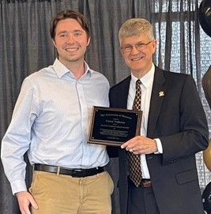
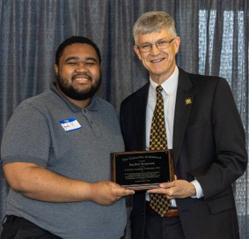
have gone above and beyond expectations. It is one of the highest honors MU offers based on academic distinction alone. Jayden Francois is a senior physics major from Kansas City, Missouri. Corey Valleroy is a senior double major in physics and mechanical engineering from St. Peters, Missouri.

Corey Valleroy (left photo) and Jayden Francois (right photo) each receive their award from Jim Spain.

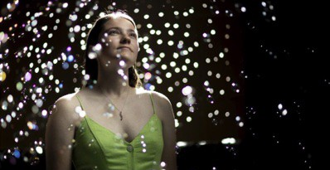
Vicki Kuhn, a graduate student in Mizzou’s Department of Physics and Astronomy, was awarded the AAS Chambliss Astronomy Achievement Award for her ground-breaking research. Photo: Sam O’Keefe / University of Missouri.
Mizzou Astronomy graduate student Vicki Kuhn, a student of Professor Yicheng Guo, has recently published her ground-breaking research on the evolution of spiral galaxies in the early universe in The Astrophysical Journal Letters. She presented her research and shared this discovery at the 244th American Astronomical Society’s (AAS) meeting held this summer in Madison, Wisconsin. In recognition of her exemplary research, she was awarded an AAS Chambliss Astronomy Achievement Award for her poster presentation on

this research. A ShowMe Mizzou article by Eric Stann, describes the work of Yicheng Guo and his research team, led by Vicki Kuhn, where they discovered that spiral galaxies were more common in the early universe, as early as 2 billion years after the universe formed, meaning galaxy formation happened more rapidly than previously thought.

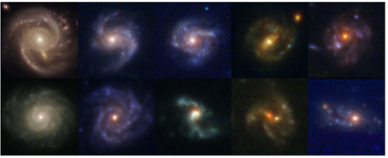
Some of the spiral galaxies studied by the researchers in the study. Photo courtesy Vicki Kuhn.

The published article is “JWST Reveals a Surprisingly High Fraction of Galaxies Being Spiral-like at 0.5 ≤ z ≤ 4,” in The Astrophysical Journal Letters. Additional co-authors are Yicheng Guo, Alec Martin, Julianna Bayless, Ellie Gates and AJ Puleo. Citation: Vicki Kuhn et al 2024 ApJL 968 L15. This project was supported by University of Missouri Research Council grants and the Missouri Space Grant Consortium.

Julianna Bayless and Ellie Gates presented their research using the James Webb Space Telescope to examine dark matter at the 2024 University of Missouri System Undergraduate Research Day at the Capitol. Thirteen Mizzou students participated in the Research Day. The event gives students an opportunity to showcase their accomplishments and allows elected officials to see firsthand the exciting innovations taking place at MU and other system universities.

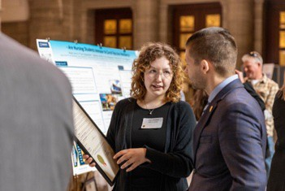
Julianna Bayless discusses her work using the JWST to examine Dark Matter. Photo by Abbie Lankitus

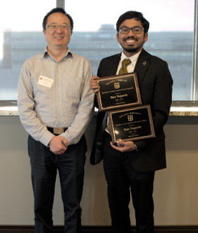
Profesor Yicheng Guo and Teja Teppala with awards presented at the 11th Annual Graduate and Postdoctoral Awards
Teja Teppala, a fifth-year graduate student in the department received the Sandra K. Abell Science Education Award and the Mary Elizabeth Gutermuth Award for Community Engagement from the Mizzou Graduate School at the 11th Annual Graduate and Postdoctoral Awards. The Sandra K. Abell Science Education Award recognizes the outstanding achievements of a graduate student pursuing PhD studies in any natural science discipline who has demonstrated a dual passion for research and teaching. The Mary Elizabeth Gutermuth Award for Community Engagement supports a graduate student who has a history of and interest in community service through engaged scholarship.
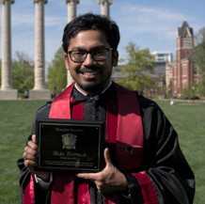
Teja was tapped into the Rollins Society Class of 2024 at the 97th

Tap Day at the University. Rollins Society is one of the six secret honorary societies at Mizzou. During Mizzou Tap Day, the Rollins Society inducts eight graduate and professional students whose record of service affirms the importance of the Society’s watchwords Officium (Duty), Fides (Faithfulness), and Ductus (Leadership).

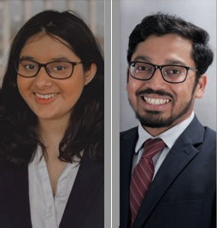
MU Remington Award recipients: Vishvi Aurora and Teja Teppala
Physics graduate student Teja Teppela and Vishvi Aurora, an undergraduate student pursuing a dual degree in biological sciences and physics, were two of four MU students (seven across the University of Missouri System) selected for the second class of recipients to receive the Remington R. Williams Award from the University of Missouri System recognizing their service outreach at MU. The award is the highest non-academic award bestowed on students by the Board of Curators and is given in memory of Remington Williams and his outstanding service as student representative to the board from 2020 to 2022. Teja serves as the outreach coordinator for the Physics and Astronomy Graduate Student

Association and is co-lead for the Graduate Professional Council’s programming committee. He also is a leader of the College of Agriculture, Food and Natural Resources’ international student group. Vishvi serves as a student ambassador for the Office of Undergraduate Research and is a student representative for the Chancellor’s Committee for Persons with Disabilities and an undergraduate representative for the Chancellor’s Committee for Libraries.

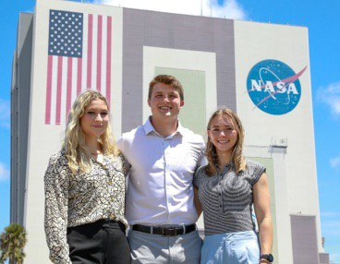
Physics major and Mizzou Volleyball player Marina Crownover, Mizzou Football’s Jack Meyer and Mizzou Soccer’s Leah Selm in front of the Vehicle Assembly Building at NASA’s John F. Kennedy Space Center.
Photo courtesy of NASA
Physics major and Mizzou Volleyball athlete Marina Crownover was selected by NASA to participate in a prestigious summer micro- internship at the John F. Kennedy Space Center. NASA selected only seven college students for the internship, with three MU student athletes chosen for the group. Katie Martinez, assistant athletic director for student-athlete career development at Mizzou Athletics assisted in the competitive application process. NASA’s Student Volunteer Experience is a week-long educational program designed for college students who are unable to participate in traditional summer-long internships because of other commitments. Crownover worked

with some of NASA’s integration and vehicle systems engineers at KSC.

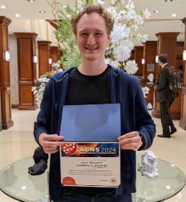
David Beckwitt received the 2024 Outstanding Graduate Student Research at the American Conference on Neutron Scattering in Knoxville, TN held June 23 – 27, 2024. David’s advisor is Paul Miceli.

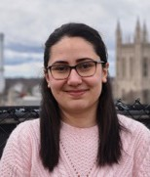
Dallar Babaian received an American Physical Society Division of Materials Physics Ovshinsky Travel Award in March and an MU Graduate School Professional Presentation Travel Award in April. Dallar’s advisors are Suchi Guha and Ping Yu.

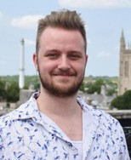
Jacob Cook was selected for the Department of Energy Office of Science Graduate Student Research (SCGSR) program. He is one of 86 graduate students selected nationally for this program. He will study materials sciences and chemistry for microelectronics at Oak Ridge National Laboratory in Tennessee. Jacob’s advisor is Guang Bian.

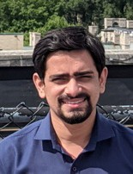
Tapesh Gautam placed second in the 40th annual Research and Creative Activities Forum poster presentation organized by the MU Graduate Professional Committee in April. Tapesh’s advisor is Sashi Satpathy.

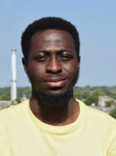
Post doc Dr. Katie Schaefer (Gavin King’s lab) received an early career microbiologist of the year award. This international recognition is from the Microbiology Society.

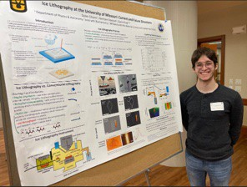
Abeeb Ajibade received the Henry Mitchell Scholarship, funding him as a University of Missouri/University of the Western Cape exchange student for two months. Abeeb’s advisor is Xiaoqin Zou.

Undergraduate students Cory Valleroy, Connor Nance, and Dylan Chiaro received Student Presentation Awards at the American Physical Society Prairie Section Fall 2023 Meeting.
Dylan Chiaro at the APS Prairie Poster Session

Undergraduate student Elizabeth Conley and recent PhD. graduate Dylan Weaver, both of Professor Gavin King’s lab, won travel awards to present research at the 2024 Biophysics Society meeting in Philadelphia, PA.

Undergraduate students Ellie Gates and Mathieux Harper received Mizzou Forward Undergraduate Research Training Grants this spring. These grants help finance STEM students already in established research programs to enhance their graduate school opportunities.

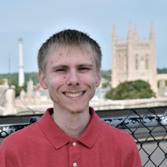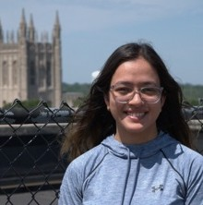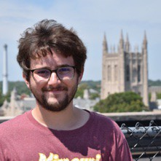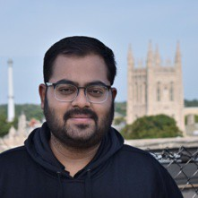

Christopher Achammer (Illinois State U. )

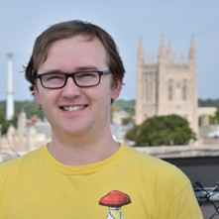
Max Doering
(Indiana U., Bloomington)
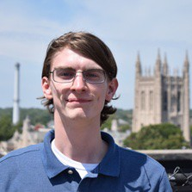
Kristopher Luck (Murray State U. KY)
Diya Bansal
(U. Nevada, Reno)

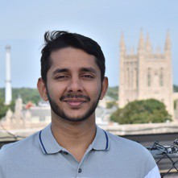
Ashan Gunarathna
(U. Colombo, Sri Lanka)

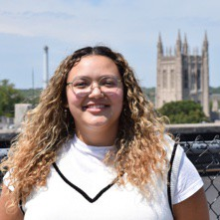
Brianna Montalvo (Rowan U., NJ)
Erin Brady
(MST, Rolla, MO)
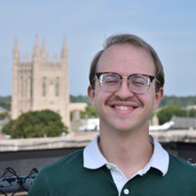
John Horne (U. Iowa)

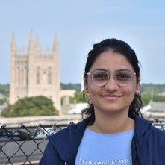
Akansha Negi
(IIT Madras, India)
Alankit Dey
(IIT Madras, India)
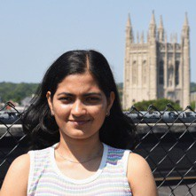
Aparna Joshi
(U. Mumbai, India)
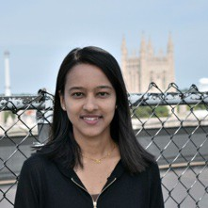
Prativa Sharma (Tribhuvan U., Nepal)

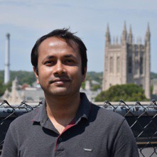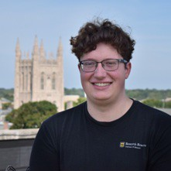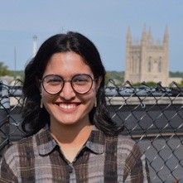

Rahgeer Yeassin
Our New Graduate Students
(U. Dhaka, Bangladesh)
Carson Ziemke (U. Missouri)
Fatema Tuj Zohra
(U. Dhaka, Bangladesh)

Student Organizations

PAGSA
This past year has been full of connection and growth for PAGSA (Physics & Astronomy Graduate Student Association) and our graduate student community. We've hosted a range of events and programs that brought us all together in fun and meaningful ways.
We had a blast at our Thanksgiving Potluck, a cozy and popular event with more sweets than we could handle! Our Spring Picnic brought some unexpected excitement when extreme rain forced us indoors to the physics library, but it turned into a lively gathering, even attracting some curious undergrads passing by. Luckily, we had perfect weather for our Fall Welcome Picnic, held outdoors with over 70 attendees, including faculty, postdocs, and students. It was great to see everyone mingling in a casual setting. In addition to the picnics, we hosted other social events like disc golf, game nights, movie nights, and ice skating, offering plenty of opportunities to relax and connect outside of the lab and classroom.
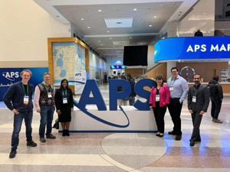
Our Mentoring Program thrived this year, especially with a larger group of new students joining us. We now have 18 grad students actively participating, helping new members navigate the ups and downs of grad school. It's been amazing to see these supportive relationships blossom. The journal clubs, dubbed TAP (Title, Abstract, Plot) Hour, have also been a highlight, offering a supportive environment for practicing public speaking and presentations. Students got to prep for American Physical Society and Biophysical Society

Current and alumni students, postdocs, and
faculty at the APS March Meeting 2024

PAGSA also made a significant impact through outreach this year. On April 8th, we coordinated an eclipse event in collaboration with MU Extension, setting up telescopes and handing out eclipse glasses on campus at Lowry Mall. The event drew more than 1,000 people, and
conferences, and we enjoyed a few lighter talks too, like one on the quirky Ig Nobel Prize winners!
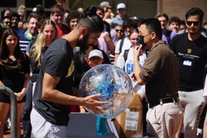
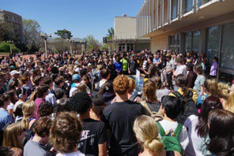
Left photo: Deepesh Sigdel and Haoing Yan talk about the celestial sphere while Gourab Nandi (right) looks on at Lowry Mall. Right photo: over 750 people attended the event. Photos taken by Frida Qi, a graduate student in the School of Journalism; on Instagram as @frida_qi_photography/ Website: https://journalism.missouri.edu/people/frida-qi-xin-qi/

a group of students even traveled to Poplar Bluff in the path of totality, where they shared the eclipse experience with over 2,500 attendees. Beyond this, graduate students partnered with MU Extension for visits to 4-H clubs in Boone County schools, engaged with the hard of hearing community through DeafLEAD, and gave an outreach presentation at the Moberly Correctional Center. Our students also volunteered at the Columbia Young Scientist Expo in March and at our department's Annual Open House, spreading a love for science to a wide range of audiences.

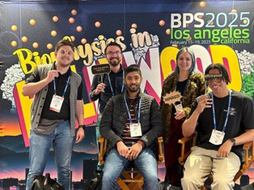
BPS Los Angeles
A big thank you to everyone who helped make this year such a success. We’re looking forward to more great moments with PAGSA in the coming year!

News contributed by Dallar Babaian, PAGSA president.

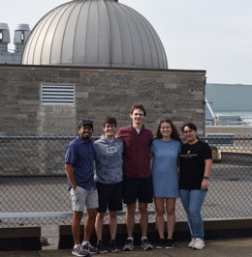
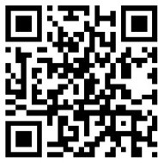
Scan this QR code to Follow PAGSA on Facebook and stay up to date.

PAGSA Officers L to R: Teja Teppala (Director of Public Outreach and GPC Representative), Dylan Chiaro (Vice President and Treasurer), Bradley Faison (Secretary), Jenna Bologa (Director of Social Events), Dallar Babaian (President)

Mizzou Women in Physics and Astronomy

MOWiPA (Mizzou Women in Physics and Astronomy) recently celebrated its first year as an organization! Our main goals are to provide a voice for the women and gender minorities within the Physics Department, to foster connections with its members that will last beyond their time here, and to enhance the academic pursuits of the women in the department. It has been an exciting and fun filled year. In the fall, we became an officially recognized group on campus, had pumpkin painting fun, and worked on creating/updating our CVs using LaTeX. In the spring, we applied for and received $1000 from an APS Women in Physics Grant to help fund some of our activities for this upcoming year. We wrapped up our first year with a brunch and we hope to see some new and old faces this school year! Professor Maria Mills is faculty advisor for the group.
News contributed by Vicki Kuhn, MOWiPA president
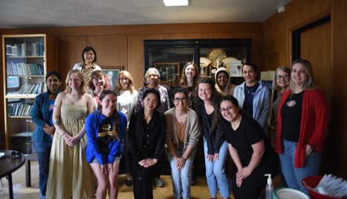
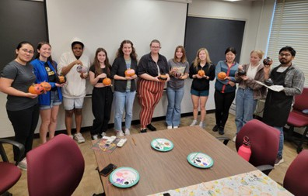

MOWiPA was a recipient of the APS Women in Physics Grant in 2024.
Members enjoyed socializing over Halloween pumpkin painting

Society of Physics Students
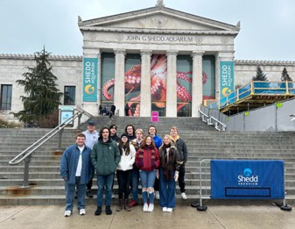
SPS had an exciting year! We kicked off with our annual Liquid Nitrogen Ice Cream Social and hosted a variety of events throughout the year. These included student research presentations, faculty talks, and fun trivia nights. We also organized sessions on general physics topics, graduate school and REU applications, and the latest news from the physics community. A highlight was our graduate student panel, where undergraduates had the opportunity to ask questions about life in graduate school.

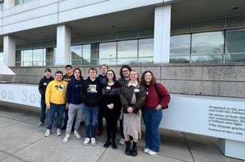
Our regular attendees grew from about five to over

Argonne National Laboratory: Front row: Hunter Lucker, Mathieux Harper, Max Sanson, Gracye Allen, Ellie Gates; Back row: Danny Vollmar, Grant Buechner, Asher Smith, Harrison Davison, Julianna Bayless
Shedd Aquarium: Front row: Hunter Lucker, Patrick Hayden, Gracye Allen, Julianna Bayless, Ellie Gates; Back row: Grant Buechner, Danny Vollmar, Harrison Davison, Asher Smith, Mathieux Harper, Max Sanson

fifteen students, a trend we aim to continue!
In January, we took a trip to Chicago, IL. Twelve students visited Argonne National Laboratory, Shedd Aquarium, the Museum of Science and Industry, Fermilab, Adler Planetarium, and Millennium Park. We look forward to a similar trip this year!
News contributed by SPS President Julianna Bayless

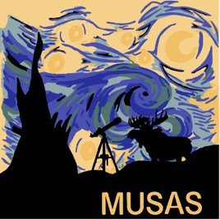
MU Astronomy Club
The MU Student Astronomical Society (MUSAS) has kept busy this year! We focused on growing our membership, both within the physics department and outside of it. This year, we have about 20 active members, maintaining our levels from last year and far exceeding numbers from the year prior. Currently, about half of our members are physics majors and the other half are from other disciplines. Our meetings over the past year included a trip to Laws Observatory, astronomy research presentation (with an emphasis on how to get involved in research and apply for REUs), a space movie night, astronomy trivia, and, of
course, we continued our monthly stargazing nights at Eagle Bluffs. Through our various events, we try to emphasize outreach to the general public and encourage students to get involved in scientific research.
The highlight of the past year was our annual stargazing spring break trip. This year 8 Mizzou students traveled to Buffalo National River in Arkansas. Although it was cloudy for much of our stay, we still got to hike, explore the river, and talk to a park ranger about astronomy, since the park is an International Dark Sky Area. Luckily, on the last night of the trip, a few of our members got a glimpse of some beautiful stars. We plan to continue the spring break tradition this year with a trip to a different dark sky area!
News contributed by club president Ellie Gates

Recent Physics Leaders Meetings

Our Physics Leader alumni meetings are held annually. The Physics Leaders are always interested in adding new members, and any alumni can attend the event.
A general outline for the fall meetings includes briefings from Department Chair, Prof. Paul Miceli, Director of Graduate Students Prof. Suchi Guha, and Director of Undergraduate Studies Prof. Silvia Bompadre. Our students provide updates on our student organizations. The Dean of A&S Cooper Drury drops by to talk about A&S topics and answer questions from the alumni. There is an opportunity for a panel of the attending leaders to meet with the students and talk their career experiences. The department selects up to four undergraduate and four graduate students to make 15-minute research presentations. As part of their giving back to the department, Physics Leaders evaluate and award first, second, and sometimes third place monetary prizes to selected student presenters. A Friday evening event with socializing and dinner is held where these student awards, faculty recognition awards, and a department Distinguished Alumni are announced and awarded.

2023
The 2023 annual meeting was held on October 10-11. During the Friday meeting following other department briefings, students Julianna Bayless talked about Society of
Physics Students activities and Vicki Kuhn summarized PAGSA (Physics & Astronomy Graduate Student Association) happenings.
Following lunch, Paul Miceli, with Ronald Boain, presented the Boain Dissertation Award for best doctoral dissertation to Dr. Katherine Schaefer.

Alumnus and Physics Leader Dr. James Seeser was selected as the recipient of the Distinguished Alumni Award. As Jim was not able to attend, Paul Miceli presented the award via Zoom.

Katherine Schaefer, Paul Miceli, Ron Boain

Jim Seeser
A founding and long-time member of Physics Leaders, Dr. Seeser was recognized not only for his career and leader/department contributions, but also for his work as a volunteer and philanthropist for numerous organizations including the Central Institute for the Deaf, the Washington University Program in Audiology and Communications Sciences program, FIRST® (For Inspiration and Recognition of Science and
Technology) Robotics Competition, and Jennings High School.
The Friday evening dinner and awards presentation was held at the Holiday Inn Convention Center
Paul Miceli and Physics Leaders President John Shumway presented 2023 Physics Leader’s Awards for the Friday afternoon student presentations. Outstanding
Undergraduate Presentation 1st place was presented to both Ellie Gates and Julianna

John Shumway & Paul Miceli present First
Place for Undergraduate Presentation to Ellie Gates, & Julianna Bayless
Bayless. Outstanding Graduate Student Presentation Awards went to 1st place - Dallar Babaian, 2nd place - Dylan Chiaro,

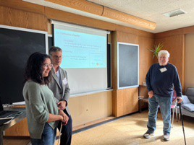
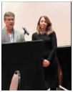
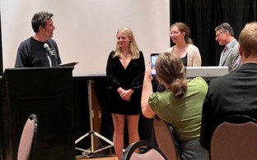
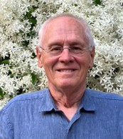
3rd place – Randy Burns. Paul Miceli presented Faculty Recognition Awards to Silvia Bompadre, Haojing Yan, Suchi Guha, and Ioan Kosztin.

Paul Miceli, Silvia Bompadre

2023 Graduate student award winners: Dylan Chiaro (2nd), Randy Burns (1st), Dallar Babaian(1st)

2024
The 2024 Physics Leaders meeting was held October 11-12. In addition to the annual “state of the department” briefings, PAGSA President Dallar Babaian talked about graduate student activities over the past year and SPS President Julianna Bayless updated the leaders on undergraduate activities. Chair Paul Miceli along with Ron Boain presented the Boain Dissertation Awards to Randy Burns (1st place) and to Ryan Smith (2nd place) over Zoom as they could not attend in person.
Faculty, students and alumni again enjoyed an evening dinner at the Holiday Inn Executive Center.
Paul Miceli and Physics Leaders Chair Vann Priest presented the Outstanding Student Presentation Awards to undergraduates Evan Restuccia and Donovan Flagg, who tied for 1st place, and to graduate

Ron Boain and Paul Miceli in a Zoom call with Randy Burns and Ryan Smith.

Vann Priest and Paul Miceli present
undergraduate presentation awards to Donovan Flagg and Evan Restuccia, who tied for 1st place
students Tapesh Gautam, 1st place; Arash Ghobadi, 2nd place; Jenna Bologa, 3rd place.

Chair Paul Miceli presented Faculty Enhancement Awards to Gavin King, Aigen Li, Deepak Singh, Carlos Wexler, and Ping Yu.

Vann Priest, Tapesh Gautam, Sashi Sitpathty (advisor), Paul Miceli

Paul Miceli and Ronald Boain Ronald Boain with his wife
Catherine and family
The special award of the event was the Physics Distinguished Alumni Award, presented to Ronald Boain. Ron was recognized for his long and

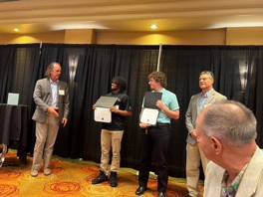
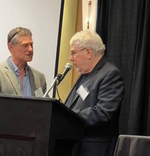
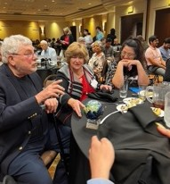
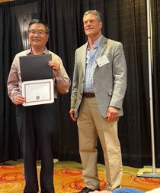
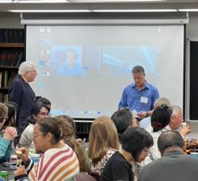
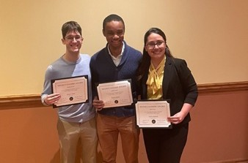
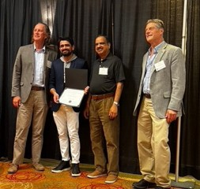
varied successful career in aerospace at TRW, Martin Marietta Aerospace, and JPL on many projects, such as optimizing trajectory designs for spacecraft, and working in critical programs such as CloudSat, for which he received NASA’s Exceptional Achievement Medal. Ron and his wife Catherine have also invested in our students through the Ronald J. Boain and Catherine J. Rangel Boain Endowment fund, the annual Boain PhD Dissertation Award in Physics, and the Boain PhD Student Travel Fund.

Ping Yu and Paul Miceli

In Memoriam

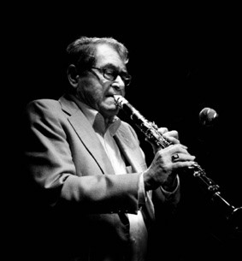
Former MU professor Joseph E. Willett of Columbia, Missouri passed away at the age of 94 on November 6, 2023. He was born in Albany, Missouri on June 9, 1929, and completed his undergraduate and graduate work at the University of Missouri-Columbia, receiving his Ph.D. in 1956, working with Bernard Goodman in the area of quantum statistical mechanics.
After working in governmental and industrial research positions he returned to the University of Missouri in 1965 as a professor where he taught in the Department of Physics and Astronomy for over 40 years. His research in nuclear fusion
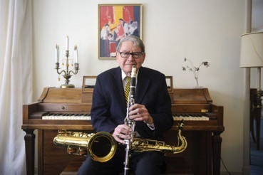
was intentionally designed to help carve a path for clean energy. Although he was a physicist by day and loved to teach graduate and undergraduate students, he was a jazz musician by night and organized his first band at the age of 13. Dr. Willett was a talented piano player, but tenor sax and clarinet were his passion. Well-
known in the local music scene, he played in venues all over Columbia for over 50 years and was considered to be one of the best clarinet players of his era. Dr. Willett retired from the University in 2004.

Professor Willett’s full obituary can be found on the Columbia Tribune website.
Information from the Columbia Daily Tribune.

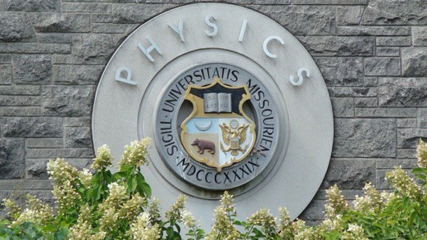

If you know a young high school student interested in a science career, there are many options with a degree in physics. Check our website: https://physics.missouri.edu/undergrad/resources

To visit the department contact MU Office of Admissions
230 Jesse Hall
Columbia, MO 65211-1300
phone: 573-882-7786
fax: 573-882-7887
email: mu4u@missouri.edu


College of Arts and Science
Department of Physics and Astronomy University of Missouri
Communiqué is published annually by the Department of Physics and Astronomy at the University of Missouri.

Editorial Oﬃce
Department of Physics and Astronomy 223 Physics Building
Columbia, MO 65211
Phone: 573-882-3335
E-mail: umcasphysics@missouri.edu Web site: physics.missouri.edu

Editorial Board Linda Godwin Paul Miceli

The department appreciates hearing from alumni and friends. Send announcements or milestones to the address listed above.
223 Physics Building
Columbia, MO 65211



Check us out on Facebook: https://www.facebook.com/MUphysics
Update your contact informa1on, through the MU Alumni Associa1on website: website: h<p://www.mizzou.com/.
You do not need to be a member to update your informa1on.

Do you know a department alumnus that you want to nominate for a Department of Physics & Astronomy Dis1nguished Alumni Award? Visit this website for more informa1on:
https://physics.missouri.edu/alumni-and-giving

We welcome career proﬁles of our alumni - email us
at umcasphysics@missouri.edu with your story and we will include it on our webpage.

Department news: hWps://physics.missouri.edu/news
If you didn’t also receive this newsleWer via email , please update your email address at hWp://www.mizzou.com (Alumni Oﬃce)

